**Topo-Bathymetric LiDAR for Monitoring River Morphodynamics and Instream Habitats—A Case Study at the Pielach River**

In this survey the Airborne LiDAR Bathymetry (ALB) approach has been taken with a 3-year long survey. The VQ-820G and VQ-880G scanner has used in this survey and the echoes are recorded to generate the waveforms. DTM filtering model (Digital Terrain Model), DWM model (Digital Water Surface), DTM-W (Digital Terrain Model of the Watercourse) and DoD (DEM of Differences model) has been used in this case. In case of water surface modelling, the lasers are hindered by the spurious false detections and the echoes by the vegetation. As the water surface generates few echoes only it results in the formation of the sparse water in the map. It shows a bias below 2cm and a standard deviation of 3cm. In case of terrain modelling the step edges, low vegetation and areas of missing ground points are the problems in mapping. These are removed by the echo shaping. The Pulse shape deviation plays a vital role in the DTM filtering of terrain surface. The habitat modelling is done based on the MEM (Mesohabitat Evaluation Model) approach. In the results, to estimate the error of the DoD, variables are assumed to be constant for respective area. The perfect classification of water bodies can’t be done due to the echo estimation. The misclassifications are considered acceptable as the off-terrain points within the river bed are classified robustly. The Flood studies data is shown with high accuracy in the meso unit scale, numerical analysis is done for modelling the bank areas and the instream habitats. For habitat modelling, the highest suitability is detected in shallow water areas. Here the bathymetric LiDAR approach is taken.

**Integration of hyperspectral and LiDAR data for mapping small water** **bodies:**

A complete water body survey is done in the mining area. The technical reclamation leaves the spoil heap to successive reclamation in the mining areas. Airborne LiDAR and hyperspectral data are used to classify water bodies. For the hyperspectral imagery CASI-1500 and SASI-600 is used. For LiDAR based data acquisition, Riegl LMS Q-780 laser scanner is used. Object based, Pixel based and Spectral angle-based classification approach is taken. Though there is a certain level of spatial misalignment in this approach. Though the standard accuracy assessment was biased due to the large water bodies. The validation per feature and validation per area is considered in this case. The shadowing effect also hindered the great level of accuracy in mapping. A feasible solution of this is taken to perform the survey in the solar noon, though the shadow outside the equatorial zone is not eliminated. In contrast to that the artificial surfaces and terrestrial or littoral vegetation is also a predominant problem for LiDAR variables. Also, the bad weather makes a problem in the data acquisition form the LiDAR. For a large area the data acquisition from the LiDAR is also a problem. Littoral vegetation was the predominant source of miss-classification. The integrated LiDAR and hyperspectral data also have been tested using pixel-based approaches which results a poor outcome in this case. Though the omission and commission error in this case is within its acceptable range.

**WATER MAPPING USING MULTISPECTRAL AIRBORNE LIDAR DATA:**

In this survey an automatic data processing workflow has been maintained using the multispectral airborne LiDAR data using the Gaussian mixture Model (GWM) and Scan Line Elevation Intensity Ratio (SLIER). GWM is used to utilize the elevation histogram, and the SILER is used to estimate the water surface data. The overall workflow is shown in the block diagram:

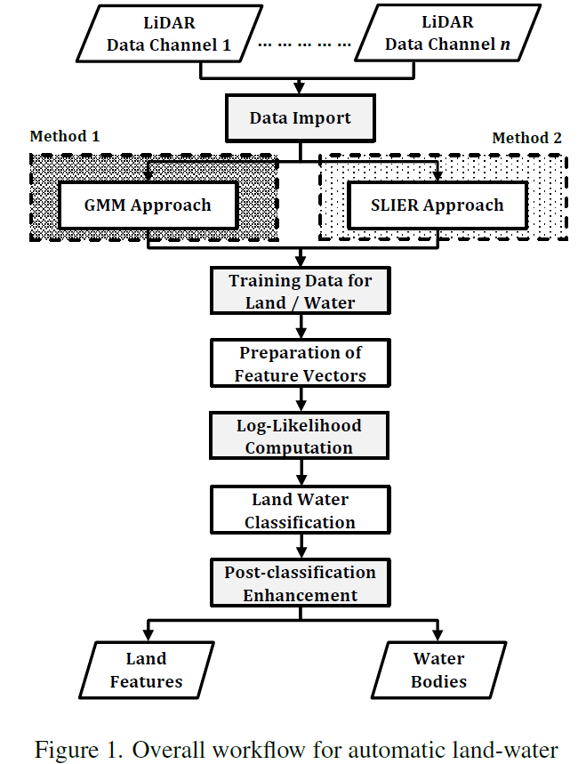

The survey is taken in various environments and at various times. And it yields very high accuracy (97.1%). The post classification enhancement plays a vital role in maintaining the high accuracy.

MAPPING RIVER BATHYMETRY WITH A SMALL FOOTPRINT GREEN LIDAR: APPLICATIONS AND CHALLENGES

https://www.oceanopticsbook.info/view/radiative-transfer-theory/level-2/the-lidar-equation#:~:text=Collecting%20the%20above%20results%20gives,u%20p%20z%20)%20%CE%94%20z%20.